Thank you for partnering with A Rocha

Please print, fill in and mail to:
A Rocha USA / PO Box 1338 / Fredericksburg, TX 78624
Questions: Email us at hello@arocha.us

Name(s) ________________________________________________________
Address ________________________________________________________
City _________________________________State ________Zip ___________
Phone _________________________________________________________
Email __________________________________________________________

GIFT DESIGNATION
__ Where need is greatest
__ Other ______________

MONTHYLY GIFT
__$30/month __$50/month
__Other $______/month

ONE-TIME GIFT
__ $50 __ $150 __ $500
__ Other $_________

___My check is enclosed

___I authorize direct payment from my bank account
I/we hereby authorize A Rocha USA to initiate debit entries to my/our checking account indicated below and the bank named below, (BANK), to debit the same to such account. I /we acknowledge that the origination of ACH transactions to this account must comply with provisions of US law. This authority is to remain in full force and effect until A Rocha USA and BANK have received written notification from me/us of its termination in such time and in such manner as to afford A Rocha USA and BANK a reasonable opportunity to act upon it.

Name(s)___________________________________________________________ Signed ______________________________________________Date__________ Signed ______________________________________________Date__________

Please fill in and attach voided check.
Bank Name _______________________________ Branch __________________
City ____________________________________State ______Zip ____________ Transit/ABA No. ____________________________________________________ Account No. _______________________________________________________

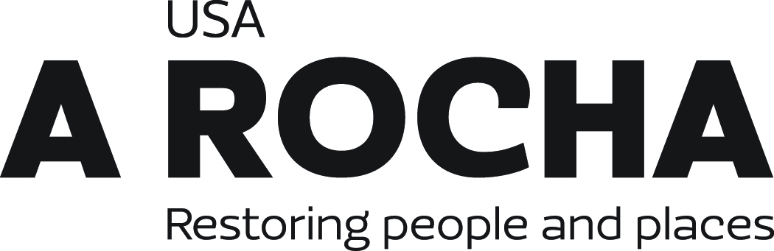

A Rocha is a 501(c)(3) nonprofit organization. All donations are fully tax-deductible, as allowed by law.
arocha.us // hellow@arocha.us

