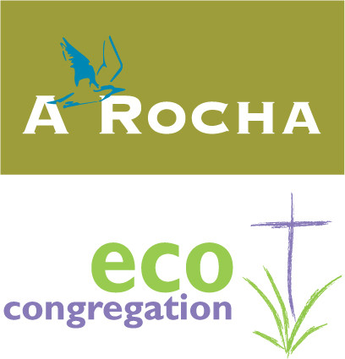

an environmental toolkit for churches
Module 7
Greening the cornerstone
Guidelines for caring for church premises

A Rocha Eco-congregation is an ecumenical program to help churches make the link between environmental issues and their Christian faith and respond in practical action in the church and wider community.
Eco-congregation (USA) is a project of A Rocha USA, a 501(c) organization
A Rocha USA, PO Box 1338, Fredericksburg TX 78624
830.522.5319 / usa@arocha.org / www.arocha-usa.org
Contents

Environmental stewardship of church premises 3
Getting started 3
Energy 3
Heating and air-conditioning 5
Lighting 6
Other energy-saving suggestions 7
The Vicarage 8
Green Electricity 8
How do I find providers of renewable electricity in my state? 9
Water 9
Waste Management 10
Real-life experiences and testimonies 11
Our Lady of Nazareth Catholic Church 11
Vineyard Church of the Rockies 12
Our Redeemer Lutheran Church, Scotia, NY 14
St. Andrew Presbyterian Church 14
Vineyard Church of Ann Arbor 15
Flagstaff Federated Community Church 16
Montevallo Presbyterian Church 17
First Presbyterian Church of Urbana 18
Westray Church of Scotland – our own wind turbine! 20
Dorking Quaker Meeting’s Award 20
Some energy actions by Eco-Congregation Churches in the UK 21
Payback time 21
Further ‘payback’ considerations 22
Case study: the Church of the Ascension, Ealing, UK 24
Case study: Callander Kirk’s DIY environmental audit 25
New build or rebuild 26
Case study: Building work at Herringthorpe United Reformed Church 26
Stories from UK Eco-Congregation Award winning churches 27
A Directory of useful organizations 28
About A Rocha Eco-congregation 29

© A Rocha USA 2012

Feedback on Eco-Congregation (USA) is encouraged.

We have attempted to credit photographs and quotes correctly.
We apologize if we have not given credit appropriately; please write to us to amend any errors.

Environmental stewardship of church premises

Church premises require care and resources to run and maintain them. Often such work is undertaken by a property steward or committee, assisted by a janitor or sacristan. These individuals or groups ensure that resources are used wisely to maintain the building in order that the worship, life and mission of their church may flourish.

A growing range of issues are involved in managing property including day-to-day running, maintenance, health and safety, accessibility and, at a time when caring for God’s creation is so important, environmental issues too. Because church premises can be fairly large, and some may be older, with an intermittent usage, it is not always easy to identify which environmental measures are the most appropriate or effective for a particular church. Module 7, ‘Greening the cornerstone’, is designed to help you consider environmental issues in your planning, decision-making and action. The suggestions given are based on good environmental practice and many of the measures offer long-term savings of both time and money.

‘Greening the cornerstone’ draws on the experience of churches who have adopted good environmental building practice, as well as expert input on the best way to maintain your church without it costing the Earth.

Getting started

Some property stewards/committees may choose to undertake their own environmental review or audit of their premises. Undertaking such a review can enable churches to prioritize actions, particularly those that can be implemented easily or with minimal cost and those which offer the greatest savings. Other actions might be considered within a rolling program of maintenance. Three general recommendations from Eco-Congregation Award winning churches are:

- Identify current good practices
- Celebrate new achievements
- Don’t try to do everything at once!

Energy

In the great range of climates experienced in the United States of America, church premises need heat, air conditioning, and light to make them useful and comfortable places for people to meet each other and worship God.
However, it is important to save energy because:

- The production of energy from fossil fuels pollutes the air with particulates, nitrogen oxides, sulfur dioxide and the elements that accelerate smog formation; they also significantly contribute to global warming
- The production of energy usually involves the depletion of finite resources from the earth
- Saving energy saves money for use in other ways by the church

The effects of climate change, or global warming, are already starting to be visible and are likely to get worse. They include rising sea-levels, an increase in storms and flooding in some places and drought in others and changes in the distribution of some disease-bearing organisms (an example is the appearance of dengue fever, spread by mosquitoes, in some southern states). People in the USA contribute as much as 50 times more to climate change than those in the poorest countries, but it is the poor who will feel its worst effects.

By implementing a few measures, churches have found that it is possible to save energy and save money, sometimes increasing the comfort of the buildings at the same time.

We have taken a lot of this material from the comprehensive EPA site: http://www.energystar.gov/index.cfm?c=small_business.sb_congregations .
The Environmental Protection Agency has partnered with close to 1500 churches to cut back on their energy costs and reduce their pollution footprint. Why not join them? (see http://www.energystar.gov/index.cfm?fuseaction=PARTNER_LIST.showPartnerResults&partner_type_id=CON&cntry_code=ALL for the up-to-date list)

The EPA has licensed professional volunteers who will offer free Energy Star certifications:

http://www.energystar.gov/index.cfm?fuseaction=pe_directory.showPESearchK12

The key thing here is conserving energy. As the US Catholic Bishops have written:

“It is clear that no overall energy strategy is free from risk to human life. Claims that there is a completely safe option are illusory; the choice is not between black and white but among shades of gray.” (USCCB Energy Policy Statement)

Heating and air-conditioning

Here are some fairly straightforward things to start with:

- Tune up your heating, ventilation and air-conditioning (HVAC) system before heating and cooling seasons with an annual maintenance contract. Like a new car, even an Energy Star qualified system will decline in performance without regular maintenance. A yearly maintenance contract costs about $100-$150 depending on the building and HVAC system, but will usually pay for itself in direct utility savings - and your system can even last years longer. A contract automatically ensures that your HVAC contractor will schedule pre-season tune-ups, in case you forget or are busy.

- Change HVAC filters (or clean if reusable) every month during peak cooling or heating season. New filters are very inexpensive, and dirty filters cost more to use, overwork the equipment, and result in poorer indoor air quality.

- A programmable thermostat can optimize the operation of your HVAC system.

  - This solid-state, electronic device automates your HVAC operation and can be “overridden” as needed for unscheduled events.
  - Your employees will always enter a comfortable building in the morning, yet you will save money.
  - These “smart thermostats” range from $25 to $150, depending on features.
  - Always make sure – in places that go below freezing in the winter – that there is adequate heating to stop pipes freezing.
Our Redeemer Lutheran Church in Scotia, NY purchased a new thermostat for the sanctuary which allowed them to create a different program for each day of the week. ‘With the old thermostat, the heat was up on Saturday morning. Now, the heat is on only Sunday mornings….’ - with significant cost savings (http://www.ourredeemer.cc/creationcarelinks.html)

- Control direct sun through windows depending on the season and local climate.

  - During cooling season, block direct heat gain from the sun shining through glass on the east and especially west sides of the building. Depending on your facility, options such as “solar screen,” “solar film,” awnings, and vines can help.
  - Shade trees (deciduous trees) can attractively shade the building, and offer wildlife interest, especially if native to your region (consult http://wildflower.org/collections/ for recommended species). Because they lose their leaves in the winter, these trees will allow the windows to act as passive solar devices in the wintertime.

- Use fans. Comfort is a function of temperature, humidity, and air movement. Moving air can make a somewhat higher temperature and/or humidity feel comfortable.

- Consider installing solar voltaic panels to generate electricity. Place solar-absorbing panels on the roof(s) for hot water and reduction of heat build-up within the building. This is exactly what the parish of Our Redeemer Lutheran Church in Scotia is doing. ‘The congregation is installing a photovoltaic system on the church's roof that is expected to save $2,400 annually in electricity costs. Parishioners tapped into a state green energy rebate program and used a memorial gift to cover the cost of the $94,000 installation.
Pastor Dennis Meyer said the system will supply electricity to the church for the next 25 years. "When the sun shines, we will put electricity into the grid and we will draw from the grid at night," he said.’ (http://www.ourredeemer.cc/creationcarelinks.html)

- In the summer, hold more services and other activities outside.

- Plug leaks with weather-stripping and caulking. Caulking and weather-stripping let you manage your ventilation, which is the deliberate, controlled exchange of stuffy inside air for fresher outdoor air. To learn more about indoor air quality in your building visit www.epa.gov/iaq

- Take comfort from the fact that it is not possible to heat a church to the satisfaction of an entire congregation. Some people will always be too hot while others are too cold. The best that can be done is to strike a good balance

Lighting

Things you can do immediately:

- Turn off lights (and other equipment) when not in use. High utility costs often include paying for energy that is completely wasted.

- Replace incandescent light bulbs with compact fluorescent lamps (CFLs), wherever appropriate. CFLs cost about 75% less to operate, and last about 10 times longer.
- Place neatly printed ‘switch-off’ signs by lights. Consider adding a slogan, e.g. “Helping St. Jude’s care for God’s creation”
- Make full use of natural light by keeping windows clean – and adjust lighting to your needs:
  - Use free “daylighting.” This means turn off or dim your lights when daylight is adequate, or use automatic “daylight-dimming” ballasts/controls to do this for you.
  - To prevent glare, eyestrain, and headaches, do not “over-light.” Too much light can be as bad for visual quality as too little light—and it costs a lot more.

When upgrading facilities:
- Consider fitting ‘occupancy sensors’ that turn lights on if movement is detected and off after a period of no movement
- Consider upgrading to T-8 (1" diameter) fluorescent lamp tubes with solid-state electronic ballasts that are more efficient than older T-12 (1.5" diameter) tubes with magnetic ballasts.
- Install brighter, safer light-emitting diode (LED) exit signs. ‘Energy Star’ qualified exit signs can dramatically reduce maintenance by eliminating lamp replacement for about 10 years, and they use 5 watts or less compared to 40 watts in a typical exit sign.
- Seek professional advice!

Other energy-saving suggestions

Reduce the number of days when heating or air-conditioning are switched on

Many church premises, particularly halls and ancillary rooms, are used at different times by a variety of groups throughout the week. A church which heats the premises on Tuesday for a coffee morning, on Wednesday for an afternoon playgroup and on Thursday for an evening meeting is likely to use more heat than a church that combines the three bookings into one day.
Use of smart thermostats can be invaluable here.

Arrange bookings to maximize use of residual heat

Some activities require less heat than other activities. A church which heats a hall for a sedentary afternoon activity might find that there is sufficient residual heat remaining to provide background heat for a later booking involving physical activity, such as an evening badminton club, without actually needing to extend the heating period.

Grants

Some utility companies have subsidized energy saving schemes and products – check your local supply company for current offers. In fact, there are a variety of grants available to promote energy efficiency. Visit http://www.dsireusa.org/.

The Vicarage

Many churches are responsible for maintaining a house where a minister, vicar or priest lives. There are a number of steps that can be taken to improve the energy efficiency of their home, so cutting fuel costs and improving comfort. Here are some ideas.

- Installing at least eight inches’ depth of loft insulation can save around 20% of heating costs
- Houses with boilers older than 15 years are likely to benefit by changing to a more fuel-efficient model.
- Around 35% of heat energy is lost through walls that are not insulated. By installing cavity wall insulation, if appropriate, up to 60% of this heat can be saved.
- Fitting low-energy light bulbs requires an initial capital outlay but can reduce energy consumption by three-quarters and the bulbs can last up to 10 times longer, saving both money and the need to change bulbs frequently
- Up to 20% of heat can be lost by draughts around windows, doors and floors. Fitting draught excluders can save heat and money. It is important to ensure that adequate ventilation is maintained, particularly in rooms with gas or solid fuel fires
- Fitting a jacket around a water cylinder pays for itself in a year or less.
- Fitting and using timer and thermostatic controls can significantly reduce energy consumption, without any loss of comfort

Green Electricity

Green electricity is electricity produced from renewable energy sources, as opposed to from our finite fossil fuel reserves. It is environmentally desirable because the fuel source is renewable, and avoids the production of sulfur dioxide, nitrogen oxides, particulates and mercury (coal and oil) as well as carbon dioxide, the greenhouse gas (oil, coal and gas).
Traditionally the main source of green electricity has been hydroelectricity but in recent years wind installations have increased. Solar power is also entering the mix.
When you switch electricity provider to one that sells renewable electricity, nothing changes in terms of how the electricity gets into your home, and how you are billed. However, you are purchasing ‘green’ electricity and making an enormous difference in terms of pollution and your carbon footprint.

How do I find providers of renewable electricity in my state?

See http://apps3.eere.energy.gov/greenpower/buying/buying_power.shtml and http://www.epa.gov/greenpower/. For incentives to ‘go green’, visit http://www.dsireusa.org/



Remember – no electricity is totally ‘green’, that is, entirely pollution-free or ‘creation-friendly’. Wind turbines kill birds and bats and solar panels use rare elements mined from the earth. Conservation is always the greenest option.

Signing the St. Francis Pledge is an initiative of the Catholic Coalition on Climate Change which encourages all of us, but in particular congregations, to work for environmental justice, in particular in the area of climate change: http://catholicclimatecovenant.org/

(it’s not just churches that purchase green electricity – visit the very cheering site http://philadelphia.phillies.mlb.com/phi/community/rgg/index.jsp)

Water

Water not only costs money. Conserving it – even in areas of high rainfall – is an act of solidarity with those in the world who have no access to clean water.

- Fix leaks. Small leaks add up to many gallons and dollars wasted each month.

- Use sink aerators and water-efficient (dual-flush) toilets to save water.

- Install an insulation blanket on water heaters that are seven years or older, and insulate the first 3 feet of the heated water “out” pipe on both old and new units.

- When buying a new water heater, buy Energy Star qualified equipment. In areas of infrequent use consider “tankless” water heaters to reduce “standby” storage costs and waste.

- Set water temperature only as hot as needed (110-120 degrees) to prevent scalds and save energy.

- Explore installing composting toilets that use little or no water. The composting process uses heat and fresh air technology to turn human waste into a light, dry, odorless humus. These can be individual units or a central system.

- When remodeling restrooms, for the male facilities consider installing ‘waterless’ urinals.

- When landscaping, use plants native to your climate that require minimal watering and provide better pest resistance. If local code allows, consider diverting “gray water” for irrigation - or at least, install a water butt to collect rainwater for this use. If you are in a very dry area, look at xeriscaping – planting cacti and succulents adapted to your natural conditions that need very little watering. These are beautiful and their flowers will prove irresistible to bees, butterflies and hummingbirds. Dry areas are not suitable for the ‘English lawn’. More on this topic in Module 9, Planting and Conserving Eden.

Waste Management

The key expression – to save money and to help protect God’s beautiful creation - “Reduce, Reuse, Recycle.”
- Reduce paper use, for instance by double-sided printing
- Use recycled paper when you can
- Recycle non-confidential waste paper, expired church bulletins, etc.
- Set up recycling, in fact, not just for paper, but for glass, steel, aluminum, and plastic. Refer to www.earth911.com for help.
Overall, understand the full ‘life cycle’ of the products you use. What are they made of? (plastic is from a fossil fuel, glass is from a much more abundant and cleaner source). What happens to them once they are thrown away?

Real-life experiences and testimonies

Our Lady of Nazareth Catholic Church

Our Creation Care Committee at Our Lady of Nazareth began when I was employed as Ecological Educator for the Diocese. I presented a day retreat, Habits of Creation, http://appfaithecocenter.org/programs.php for a small group at OLN. Several months later we did the JustFaith program on Climate Change. This was the group that decided to continue meeting for study, sharing, and action.

Our work at OLN has included:

- Completing an energy assessment with the help of EPA's Energy Star Portfolio and a local volunteer engineer.
- Developing and supporting "clean-up" days for the water ways around our property.
- Developing a recycling center for parish functions such as picnics, large event dinners etc. We volunteer to collect the recyclables, encourage the use of reusables by washing the dishes, send the food wastes to a member who raises pigs, and generally make a spectacle of ourselves for the parish…!
- Last year we got funding and selected a landscape architectural firm to draw up a plan for an environmental landscape for the parish……
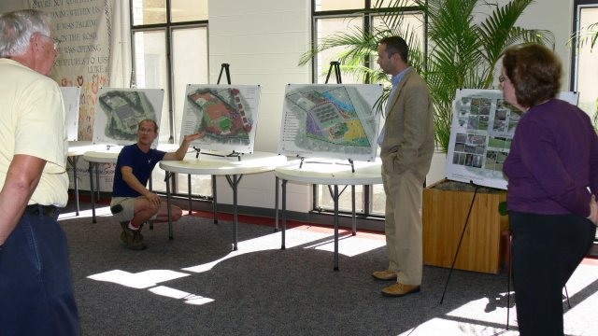

    - putting the "caring for the environment: creation" in future landscaping projects -

- Our members volunteered to join the gardeners of OLN to assist with weeding and planting.
- We assisted one of our members in presenting an interfaith environmental conference and provided the "green lunch".
- Our most recent project is the study of green burials and support of our local Catholic cemetery.

Susan Hedge, Our Lady of Nazareth Catholic Church, Roanoke, Virginia 24018, http://www.oln-parish.org/index.php

Vineyard Church of the Rockies

The Vineyard Church of the Rockies (VOTR) are enrolled in a stewardship program from the city of Fort Collins where the church is located. It is a voluntary program called Climatewise in order to reduce greenhouse gas emissions (see more at http://www.fcgov.com/climatewise/ ). This program has 4 levels (i.e. bronze, silver, gold, and platinum). We have achieved platinum level in 2012. We are the only church in the city that has achieved this highest level, and we achieved this level all on a voluntary basis!

Other things we have achieved to date:

- Participation Bike to Worship Challenge (Employee bike commuting project) - staff was challenged to bike to work beginning June 21 through August 31st with the one biking the most miles winning bragging rights. The Vineyard church is big into biking as staff and reducing the number of cars on the road. This fun and exciting challenge allowed us to reduce a total of 477.1 miles driven to & from the Vineyard. The staff participation increased by 15% in 2011 - from 170 to 200.
- Decrease in utility use from 2009 - 2011 resulting in reduction in electrical use of 3.96% and reduction in natural gas use of 9.36%.
- Roof replacement, repair (covering skylights) and white reflective coating projected to save 2-5% on energy costs for 2012.
- Community Garden provides 1,003 lbs. of organic produce to Vineyard Resource Center which distributed them to the under-resourced in Ft. Collins.
- Replaced and recycled 2 tons of copper gutters and building facia with steel replacement.
- Irrigation system overhauled and reprogrammed for efficiency and proper coverage.
- Hosted bike safety 'Train the Trainer' seminar in conjunction with The Bicycle and Pedestrian Education Coalition (BPEC) for congregants and the community to encourage safe and increased bicycle use with 25 people in attendance.

Paulo Brito, Vineyard Church of the Rockies, Fort Collins, CO 80524 http://www.vineyardotr.org

Pictures of the Vineyard Church of the Rockies community garden:

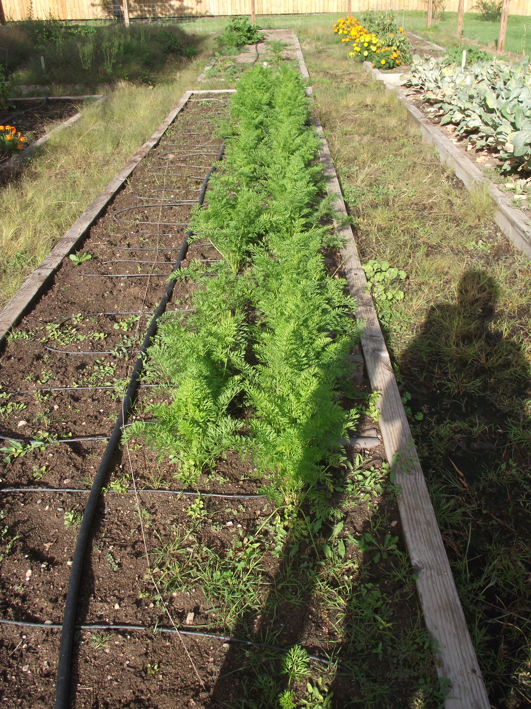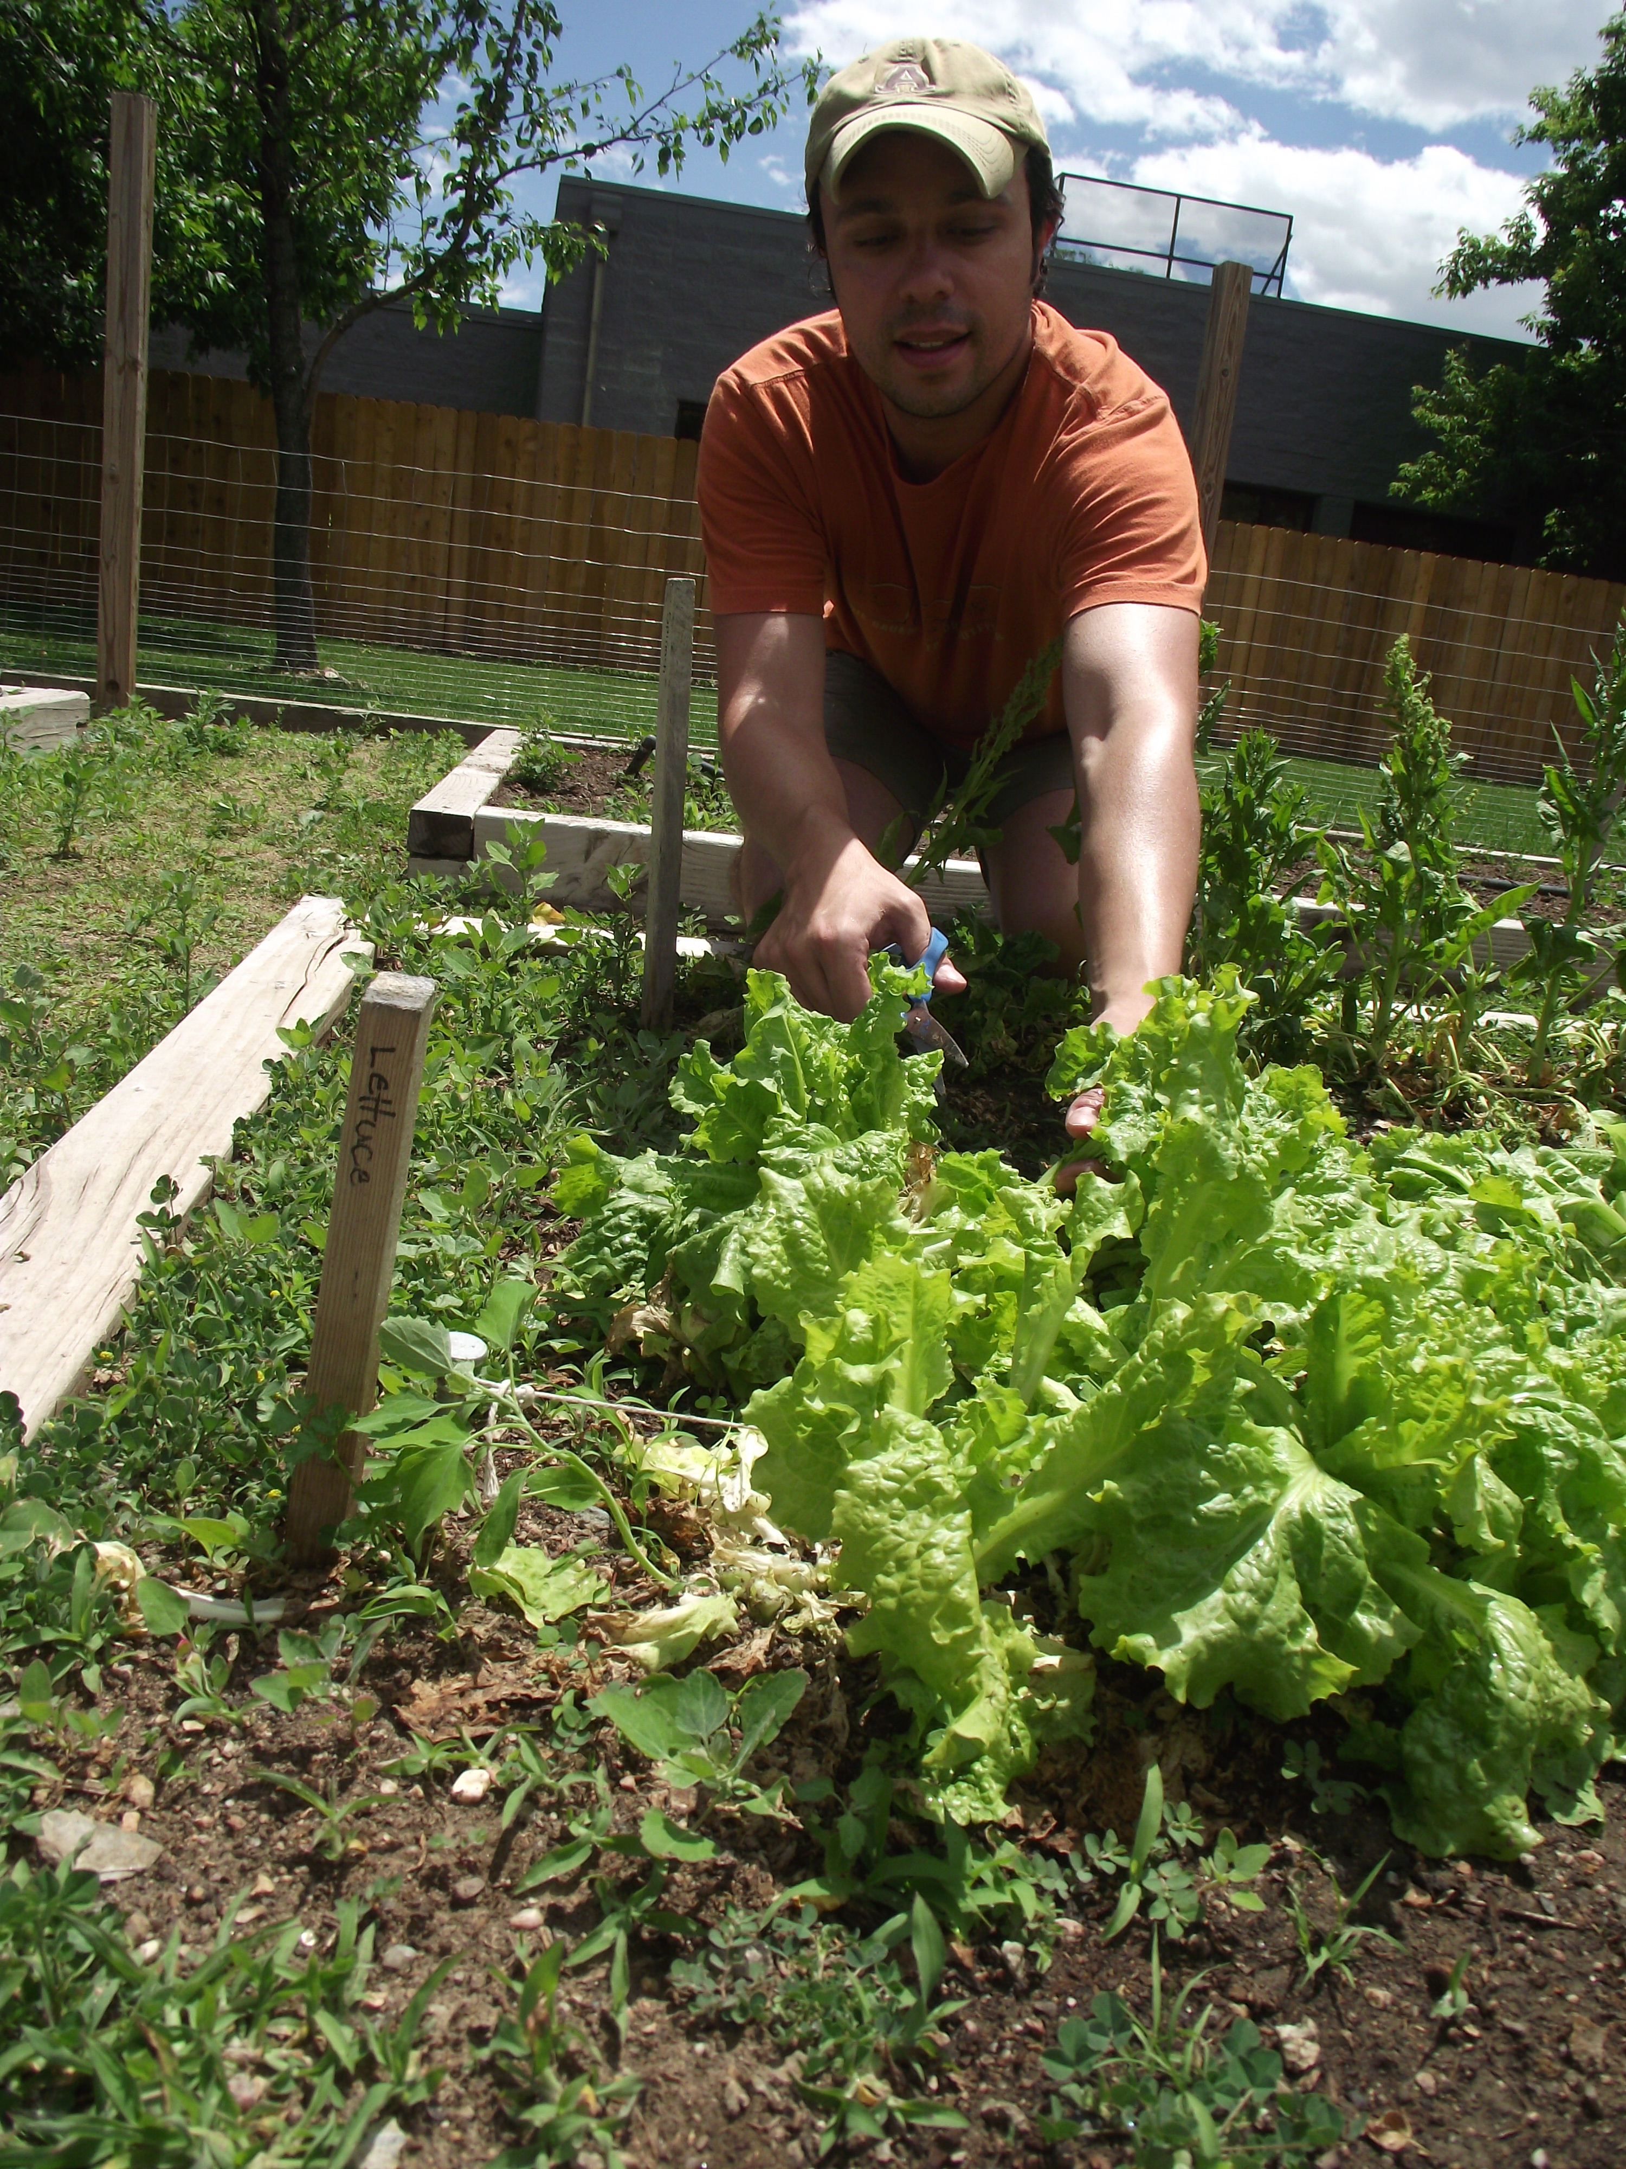

Our Redeemer Lutheran Church, Scotia, NY

As a great example of sustainability, Our Redeemer Lutheran Church in Scotia, NY thought ‘out of the box’ for Palm Sunday. ‘We purchased eco-palms (http://www.lwr.org/palms) which were harvested in a sustainable way. More of the money paid for these palms directly benefit the people that harvest them.’
(http://www.ourredeemer.cc/creationcarelinks.html)
They are also installing solar panels – mentioned above, and shown below!

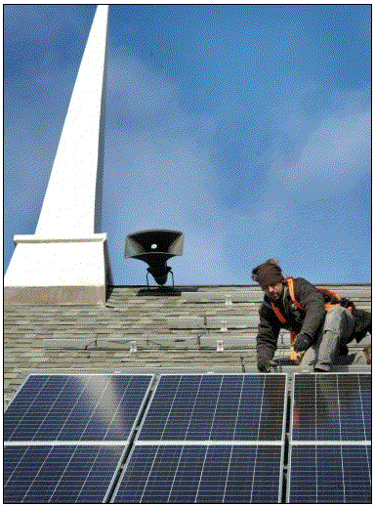

St. Andrew Presbyterian Church

In 2011, we achieved Earth Care Congregation status [from the Presbyterian Church USA], the first Colorado congregation so honored. We have incorporated the usual kinds of things (recycling, community garden, minimizing waste, outdoor worship, etc.) and have also had classes, and earth-themed worship (for 19-20 years we've had an annual Blessing of the Animals, and now have included a Blessing of the Gardens since we have community garden, a Memorial Garden, and beautiful flower gardens). Last summer we helped facilitate field trips to local environmental research sites as a run up to the Presbyterians for Earth Care biennial national conference. We want people to know that earth care is not peripheral, but central to Christian faith and life.

Thanks to a generous gift from outside the congregation, a congregational gift and a bequest, we begin installing solar panels this year. Throughout this year, we hope to continue worship, education and witness of various kinds. This spring we had a presentation from Pete Sawtell, Executive Director of Eco-justice Ministries, and an environmental designer from a local group called Populus, regarding why energy conservation and alternative energy is a spiritual issue. We continue a biblically based witness, demonstrating how environmental concern is central to our lives as members of the creation, and how we can use faith, knowledge and skills to enhance living in harmony with God's purposes on planet earth.

Stan Adamson, Pastor, St. Andrew Presbyterian Church, Boulder, Colorado. http://www.standrewboulder.org/

Vineyard Church of Ann Arbor

The senior pastor tells his story….

I attended a retreat of Evangelicals and Scientists in 2006. Leading scientists including E.O. Wilson, Carl Safina and James Hansen were there. It was an early attempt to break down the cultural barrier between our two communities for the sake of the environment. At the retreat I experience a spiritual awakening to environmental concern. It occurred when Gus Speth, the first advisor to a U.S. President (Jimmy Carter) on climate change said this: "I used to think the top three environmental problems were eco-system collapse, bio-diversity loss and climate change. And that with 30 years of good science we would be able to solve these problems. I was wrong. The top three environmental problems are selfishness, pride, and apathy. For that we need a cultural and spiritual awakening. And we scientists don't know how to do that. We need your help [speaking to evangelical leaders present.]"

In that moment I realized that many of these scientists, including those with a secular outlook, were in touch with God's heart regarding creation much more than many American evangelicals, myself included. I felt deeply contrite and humble, my eyes filling with tears. And I knew that I had to do something about it.

Our church board adopted an environmental stewardship policy--that we would work toward integrating creation care into our life of discipleship and that we would improve our environmental stewardship as a congregation.

We began to make improvements such as: improving our building's energy efficiency through new roof insulation, improvements in lighting, recycling, etc.

We encouraged the congregation in the use of CFLs, giving away 300 one Sunday.

We formed a small group of people interested in learning more about environmental stewardship. A team came out of this to plant and tend an organic garden on church property. We pray for the harvest every year and celebrate the harvest when it arrives, providing fresh food for homeless ministries in town. We began to observe Earth Day.

This past year we provided 150 trees at our Sunday services for people to take home and plant.

We developed an outreach to evangelical pastors called Creation Care for Pastors (www.creationcareforpastors.org ) through which we have distributed about 20,000 "Creation Care for Busy Pastors" booklets which we developed as an outgrowth of "Evangelicals and Scientists United to Protect Creation" [rooted in the 2006 retreat I mentioned earlier.]

I became an advocate for creation care in our denomination, Vineyard; A Community of Churches. We now have many Vineyard churches (I would estimate 20%) which have some kind of environmental stewardship emphasis, including our two largest churches

Ken Wilson, Senior Pastor (http://annarborvineyard.org/ )

Flagstaff Federated Community Church

The work of Christians for the Earth is an important part of the identity of Federated and of the community of Flagstaff. We have established a reputation as Flagstaff's "green" church. People from other churches in the area, as well as people from other walks of faith, routinely attend our events. Our numerous volunteers are active supporters of the following outreach activities:

- Environmental Policy. We drafted a church environmental policy and presented it to the Board of Trustees. It was adopted in 2009.
- Solar Energy. In 2012 we went solar! We installed 132 panels to cover 96% of our energy use, and reduce our carbon footprint by 2 million pounds.
- Energy Efficiency. Several projects to make the church facility more energy efficient have been led by Christians for the Earth, such as switching to CFLs, installing programmable thermostats, replacing exotic plants with native ones, installing a bike rack and building cupboards for ceramic coffee mugs.
- Earth Friendly Coffee Shop. The first Sunday of each month we hold the Coffee Shop in our fellowship hall, selling shade-grown coffee and other earth-friendly products such as tea, cocoa, nuts, greeting cards, ceramic mugs and canvas tote bags.
- Earth Day Celebration. Christians for the Earth works with the minister and the Worship Team to plan our church’s Earth Day celebration. We have also sponsored the Blessing of the Animals for many years.
- Sustainable Gift Baskets. We make gift baskets for new members joining our congregation, for guest speakers and to acknowledge other special occasions. The gift baskets include Equal Exchange coffee, tea or cocoa (along with information explaining these environmentally friendly products), a church coffee mug, a book on the history of Federated, a Christians for the Earth bookmark and cookies. We believe that the gift baskets are a way of connecting with new members and introducing them to sustainable products.
- Compostable Tableware. We supply compostable tableware for church events, including the Back-to-School Picnic, Vacation Church School meetings and the Fellowship Hour. Additionally, we often arrange for locally grown food to be featured at church events.
- Recycling Program. Our group of volunteers implemented a church-wide recycling program, furnishing recycling bins for rooms throughout the church, along with informational signs. We published articles in The Belltower and sponsored Moments for Mission to help the congregation understand the new program.
- Good Steward Tips. Christians for the Earth submits "Good Steward Tips" to our church newsletter, The Belltower. We also provide The Belltower with other articles covering environmental issues and Christian responses to the ecological crisis. Our members reach the congregation with thoughtful "Moments for Mission."
- Adopt a Plot. Our group initiated the program "Adopt a Plot" to help beautify the church grounds, and later organized the first "Work Day for Church Grounds." We spearheaded the effort to replace exotic plants with native species and to use reclaimed water for outside uses.

Sherry Golden, Christians for the Earth, Flagstaff Federated Community Church, Flagstaff, Arizona, http://www.flagstafffederatedchurch.org/

Montevallo Presbyterian Church

In an effort to control and minimize our environmental impacts, we established a maintenance checklist with a monthly schedule of maintenance activities performed by our church members. These activities include:

- Cleaning and changing HVAC filters
- Cleaning condensing units
- Monitoring for water leaks
- Using T8 and CFL bulbs
- Maintaining weather-stripping
- Landscaping with native plants to reduce/eliminate the need for watering
- Eliminating the use of toxic herbicides and pesticides
- Composting yard waste and leaves
- Conducting environmental audits of our facilities
- Other improvements include:
- Recycling metals, plastics, paper, and glass
- Eliminating the use of paper and Styrofoam plates and cups at church functions
- Installing ceiling fans
- Installing energy efficient windows
- Placing water heater on a timer so that it comes on only when needed
- Purchasing Energy Star appliances
- Installing programmable thermostats

Our monthly church newsletter, Grace Notes (http://www.montevallopcusa.org/news.htm), includes environmental scriptures and information. Members of our Green Team present faith-based environmental information to our community through participation in the activities of the Interfaith Environmental Initiative of Alabama.

Bill Peters, Montevallo Presbyterian Church Green Team, Montevallo, AL

First Presbyterian Church of Urbana

Recent Earth Care Team activities by this church in the areas of worship, education, facilities and outreach have been….

- Two worship services with an ‘earth care’ theme conducted each year.
- The Adult Ministries Committee, in consultation with the ECT, has decided that two earth care-themed seminar series would be provided each year. So, for example, a five-week seminar series entitled Residential Energy Efficiency, which was organized by ECT member Dave Sherwood, was provided in the fall of 2011; and a three-week seminar series entitled Reducing the Environmental Impact of the Home Landscape, which was organized by ECT member Dixie Jackson, was provided in early 2012.
- Many nature-themed outings take place.
- The EARTH CARE MATTERS bulletin board contains information on congregation and community earth care activities, Presbyterians for Earth Care quarterly newsletters, Faith in Place newsletters and recycling information. The library also contains relevant ‘green’ books.

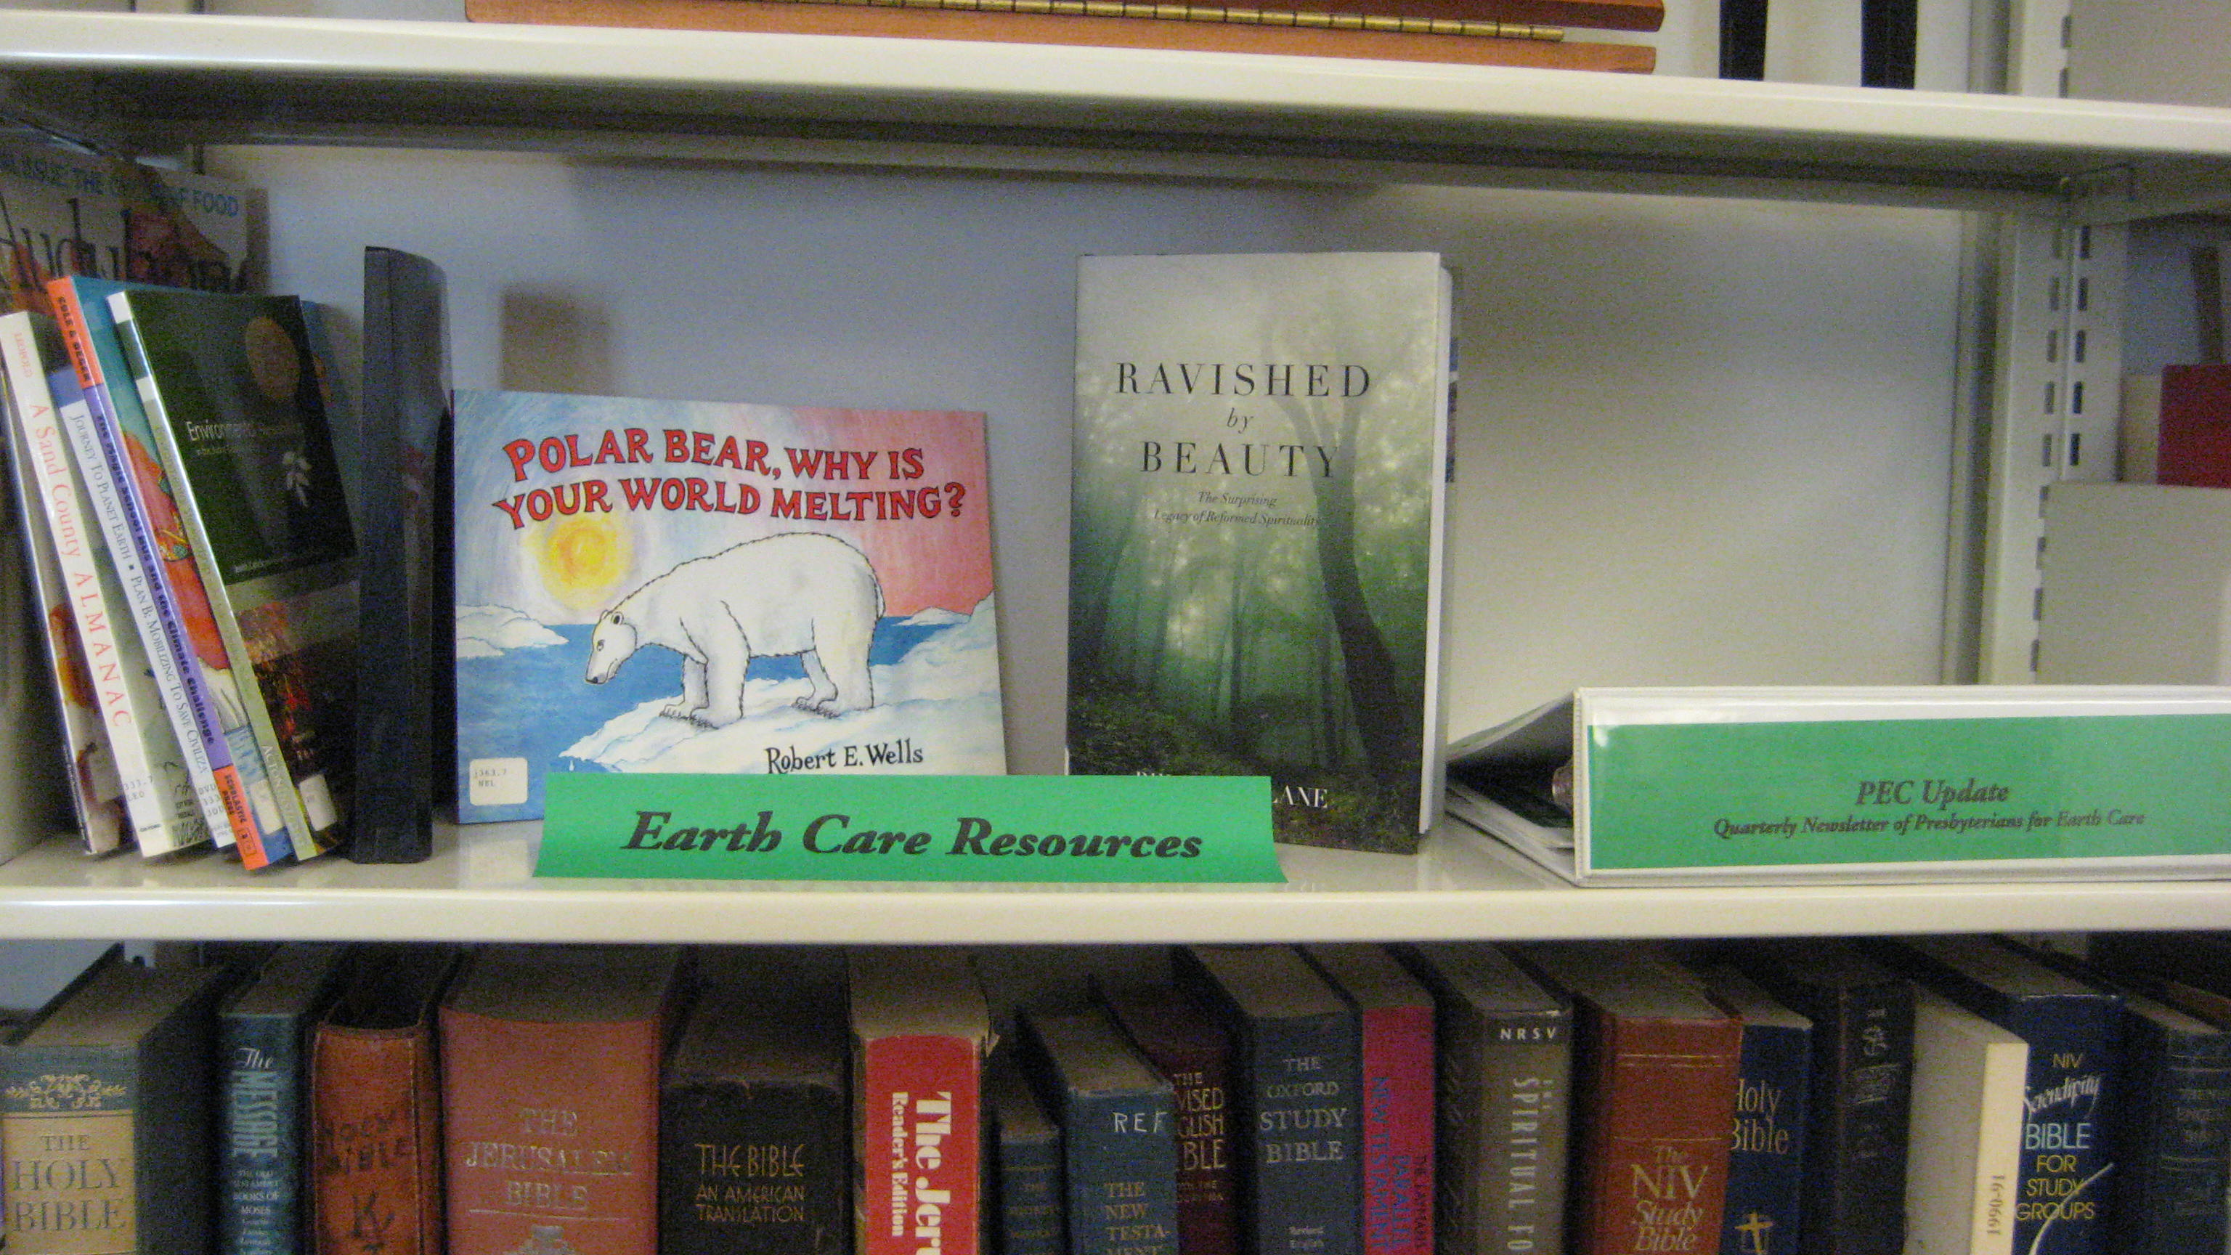

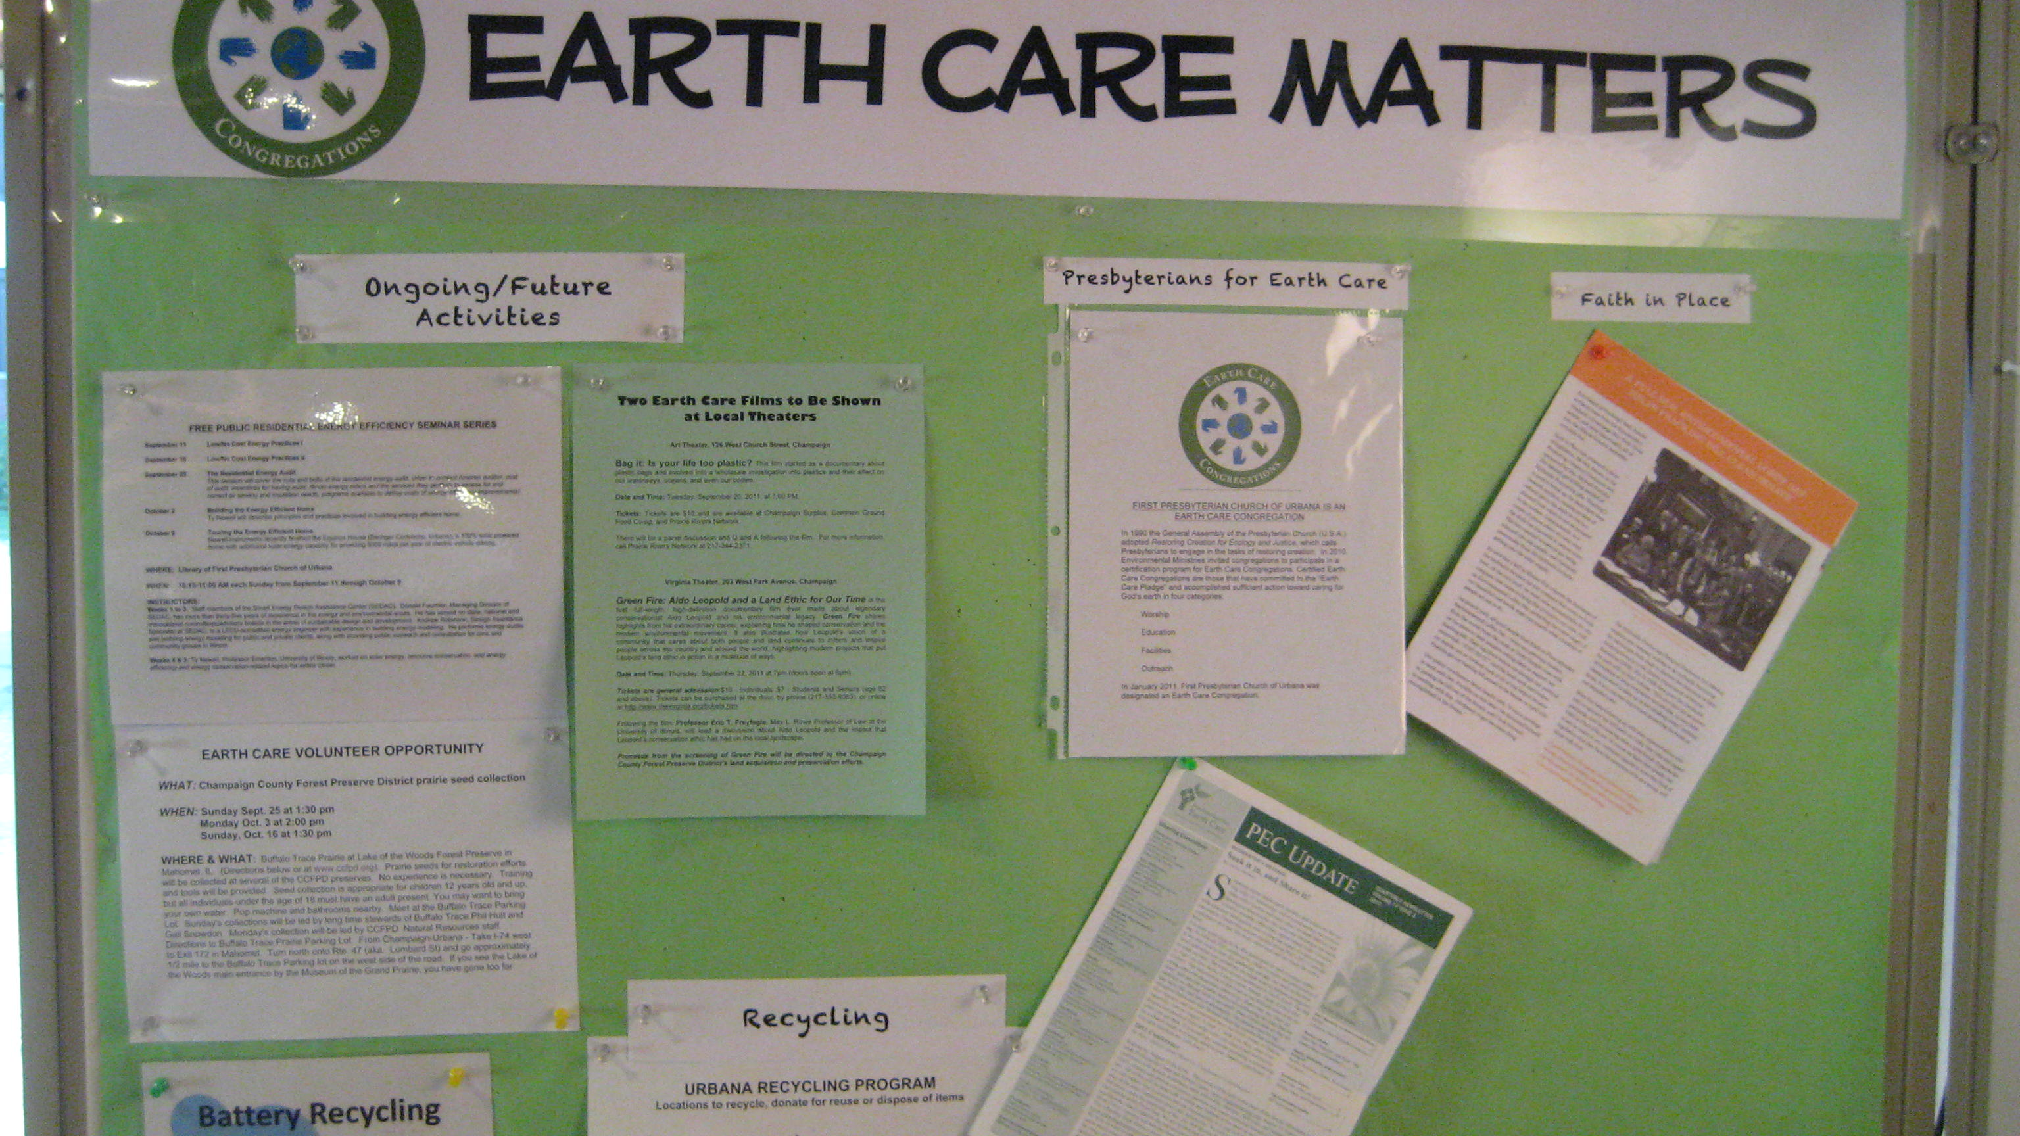

In addition – ‘The Earth Care Team is in the process of exploring the possibility that we convert to a geothermal system for heating and cooling of the church building. We have checked out potential sites for boreholes, and cost estimates are being prepared for the project. The next step in the process will be to analyze the potential costs associated with a geothermal system versus those associated with replacement of the 50-year-old boiler and 40-year-old air conditioning unit.’

Reported by O. David Sherwood, Earth Care Team Co-coordinator, First Presbyterian Church of Urbana, Illinois, http://www.firstpresurbana.org

Westray Church of Scotland – our own wind turbine!

In 2001 and 2002 Westray Church underwent extensive restoration and redevelopment to transform their cold, damp and inflexible building into one which is much more modern and comfortable. As part of the refurbishment they installed a ground source heat pump which uses natural heat from the ground to heat the church building. They then decided to pursue the idea of renewable energy further by installing a wind turbine. The main aims were to reduce the annual energy costs while at the same time increasing temperatures to a comfortable level in the building. It was also seen as very important to use a clean and environmentally friendly source of energy. The project secured funding in the form of an 81% grant from the Scottish Executive and a Scottish Community and Household Renewables Initiative (www.est.ork.uk/schri) implemented by Highlands and Islands Enterprise Community Energy Unit for Orkney and Shetland. The project was completed in March 2003 and the wind turbine now powers two storage heaters in the sanctuary and one in the vestry. The wind turbine is efficient, low maintenance and a very visible symbol of a congregation demonstrating its commitment towards God’s creation.

Note: Some churches are ideal buildings for solar installations, particularly those built on an east - west axis, as they have an extensive south facing roof.

Dorking Quaker Meeting’s Award

When I suggested my Quaker Meeting work for an Eco-Congregation Award they were not enthusiastic! They were happy for my Environment Audit to ‘green’ up the Meeting House but didn’t see the need for any award. However, as our ‘greening’ efforts progressed, the groups who hire our Meeting House began to comment positively on how ‘green’ we were, and the visible indication of our efforts came to be seen as part of our ministry. A demonstration of our witness that the love of God’s creation should be taken seriously and that by making changes in the way we live we can help to preserve the beauty and variety of the world we live in, prevent pollution, reduce injustice, and indirectly, help to prevent conflict. Also, as we became increasingly aware of the damage being done to the world, we felt it important to encourage others to make similar changes.
So, with encouragement from Eco-Congregation, Dorking Quakers changed their minds, applied for the Eco-Congregation Award and were quite proud to be the first Quaker Meeting House in the UK to receive it. We arranged to have it presented at the local Churches Together meeting to encourage other churches and achieved excellent publicity in local papers and various Quaker publications. I’ve recently had phone calls from two other Quaker Meetings now thinking of applying for the award, so have encouraged others.

Anne Brewer, Dorking Quaker Meeting, www.dorking.quaker.eu.org

Some energy actions by Eco-Congregation Churches in the UK

St John’s Church, Spittal |  | Moved smaller, mid-week meetings and services to smaller rooms
All Saint’s Church, Wretton |  | Switched to green electricity
Dorking Society of Friends Meeting |  | Installed draft-proofing
St John the Evangelist, Hurst Green |  | Fitted low energy bulbs throughout church
St Peter’s, Claybrooke Parva |  | Fitted efficient gas-condensing combi Boilers
Church of the Ascension, Ealing |  | Commissioned an energy consultation
Selly Oak Methodist Church |  | Up-rated heating with a zoned system
Kirkwall East Church |  | Incorporated low energy lighting circuits, a high standard of insulation during their building renovations
Evesham Methodist Church |  | Installed insulation above their ceiling
Dalbeattie Parish Church |  | Installed roof insulation and a high-efficiency boiler.
All Saint’s, West Bromwich |  | Created a glazed and roofed partition within their sanctuary to provide a place for midweek worship without the need to the whole church
St Mary the Virgin, Easington Village |  | The children built a model low energy house from cardboard to demonstrate good practice at home
Christ Church URC/Methodist, Ross-on-Wye |  | Gave away household energy audits at their annual fayre and a low energy light bulb (both from their local energy advice centre) to everyone who completed it
St Matthew and St James, Liverpool |  | Installed safe cycle storage facilities
St John’s, Hartley Wintney, Hampshire |  | Switched to green electricity

What energy saving measure could your church adopt?

Payback time

Some steps to reduce energy or use of other resources cost money to implement but can cut the consumption of energy or other resources so saving money in the long term. One example is installing low energy light bulbs (CFLs, LEDs). These bulbs can cost considerably more than the price of a regular bulb but they are still cheaper to install and use in the long run because:
- they last up to ten times longer than conventional bulbs, so saving the cost of purchasing nine regular bulbs and
- they use about 20% of the energy used by a conventional bulb, so the running costs are 80% less

The ‘payback’ time is the length of time it takes for the savings made to equal the cost of buying and running the bulb. Beyond this time period, use will save money compared with the cost of using a regular bulb.

Different energy saving measures can have different payback times. It is useful to consider the payback time in any energy-saving recommendations that are made. The shorter the payback time, the quicker savings are made.

Further ‘payback’ considerations

If you are considering installing new ‘plant’ (e.g. a boiler, new heating system, windows), consider a specification which offers better energy efficiency (e.g. a gas condensing boiler, a heating system with thermostatically controlled circuits, windows with low emissivity glass) and calculate the payback in terms of the additional cost of installing the plant with a better energy efficiency than standard plant against the saving in energy made.

Many householders may look for a ‘payback’ period of 2-5 years. They may not invest in energy-saving measures if the payback is greater than 10 years, calculating that if they move house in the period, they won’t benefit financially from the investment. However, a church may expect their premises to be used well into the future, and so can afford to invest in energy saving measures with a relatively long payback.

For some churches the ‘payback’ time is not as important as witnessing to their local community that they care for God’s creation in practical ways. In the past, churches used their resources to build towers and steeples not only to contain church bells but also to act as an ever-present visible witness to the place of God in their community. For some churches, witnessing to their care of God’s creation may be more important than seeking a particular payback period. Perhaps churches in the 21st century will choose to witness to the God of creation by installing photo-voltaic tiles on their roof to generate electricity rather than building a tower.

- Immediate management and audit measures  - Set the heating boiler to come on earlier in the depths of winter, but switch it to come on later and switch off earlier during milder autumn and spring periods  - Ensure that a record is kept every time the boiler is serviced together with any recommendations and pertinent data, e.g. flue gas emission figures  - Record weekly or monthly gas, electricity and water meter readings and incorporate into resource monitoring and target planning for the church  - Check the need for domestic hot water and restrict use as appropriate |  | - Low-cost or short-payback period (less than 2 years)  - Fit insulation around the heating pipes within the boiler room and move the vent from an adjacent corridor to an outside wall, to reduce internal cold draughts  - Fit thermostatic valves to radiators in vestries and subsidiary rooms  - Fit draught stripping to all external doors and lobby doors and self-closer to main lobby door  - Fit draught seals to windows where opening is required  - Replace all remaining tungsten light bulbs with compact or tubular fluorescent fittings (consider adopting high frequency type for tubular fluorescent)
- Medium cost or medium payback period (approx. 2-5 years)  - Replace time clock on the main heating boiler circuit with a controller and fit room thermostats in Nave and Chancel to provide weather compensated (variable temperature) flow with external temperature sensor, optimum start and stop (self-learning for boiler and pump) and programmable space heating by time and temperature  - Replace electric on-peak space heating: options include gas-fired condensing boiler with multi-circuit system |  | - Work at refurbishment stage or incurring longer payback (approx. 5-10 years)  - Replace gas boiler with condensing type  - Upgrade insulation to building fabric  - Insulate single glazing with fixed secondary glazing with opening frames for ventilation

Case study: the Church of the Ascension, Ealing, UK

The Church of the Ascension commissioned a Design Advice consultation through its participation in the Eco-Congregation pilot study. The church subsequently received a report outlining the nature of the building and a set of recommendations to be dealt with in the forthcoming years. The following is a summary extract of the report:

Overview of the premises

The sanctuary was built in 1939 with a church hall added in 1961. The sanctuary is of brick construction with a tiled roof with a heating system comprising a gas boiler with cast iron radiator system without a temperature control mechanism. There is no fabric insulation. The church hall, which is heated electrically, has a part barrel, part flat roof, in both areas covered in mineral felt.

Occupancy

The sanctuary is used twice each Sunday and for occasional midweek/Saturday services. The Church hall is used for school activities most weekdays and for various groups (e.g. badminton) in the evenings.

Recommendations for action

Following an analysis of the:

current fuel costs (broken down by gas and electricity and between the hall
and sanctuary)
heating plant
lighting system and controls
heat loss and insulation (doors, roof, floor, windows)

A series of actions with phased implementation was recommended (see the report on next page).

What the Church of the Ascension did…

Within the first nine months of receiving the report the Church of the Ascension implemented a number of the immediate and short-term recommendations including:

The economy tips for setting the thermostat
Installing door closers
Draught-proofing other doors and windows
Insulating pipes and undertaking alterations with recommended venting in the
boiler room

Gillian Harrison, the Green Apostle from the church who arranged the consultation commented

“The report was illuminating – it made us think about our energy use, how much we waste and how much we could save. We wish that we had known about having a professional audit six months earlier when a breakdown in our hall heating led us to replace the old electric system with a new electric one which we now realize is inefficient and expensive to run. However, now we have got the consultation report we are working our way through the recommendations and view it as our ‘maintenance Bible’ for our future program of maintenance and repairs.”

Case study: Callander Kirk’s DIY environmental audit

Callander Kirk, in Scotland, devised their own environmental audit as part of their participation in the Eco-Congregation pilot study. Their audit covered the following areas of Church life:

- Energy
- Waste incl. paper, water + miscellaneous
- Purchasing policy
- Grounds
- Transport

Having undertaken the DIY audit, they compiled a report for their Congregational Board highlighting ‘plus’ and ‘minus’ points. The following is an excerpt from their energy section:

- An old building, which has a high ceiling, thick walls and roof ventilation. The thick walls give good insulation and act as a heat sink when fully warmed up. However, the duration of use usually precludes it from being efficient. Every effort is made to use the heating as efficiently as possible

- Low energy light bulbs are used throughout the main body of the church with fluorescent lights being used for most of the remainder. There are some halogen spotlights and a floodlight which are used in specific areas.

- Windows are rarely cleaned although lighting is almost always needed when the church is in use

- Draughts from windows and doors are a problem. The main door to the church is fitted with a hot air curtain to prevent heat loss from the building when the doors are in use. It is unlikely that windows could be fitted with secondary glazing. Some doors could possibly be improved.

Recommendation: That an energy audit be commissioned for the Callander Kirk buildings to enable planning and decisions to be made on the basis of professional advice.

Callander Kirk’s DIY audit covered a number of aspects of church life, including stewardship of their church premises. It helped them to identify a number of areas of good practice, for example the installation of low-energy light bulbs, and a set of recommendations for consideration/follow-up including, in the area of energy management, to have a professional consultation/survey.

New build or rebuild

If you are considering building church premises from new, or undertaking either an extension or rebuild to existing premises, it is strongly recommended that you commission an environmental consultation to aid the development of your plans.

Additionally, bear in mind that building construction involves the use of materials, all of which have used varying amounts of energy in their production. Some, like timber, have a low “embodied energy” value, being a natural, renewable resource (if obtained from a sustainable source). Others, such as brick and stone, are natural but require the use of more energy to create the final product. Yet others, such as PVC, use high levels of energy in their production and are made from non-renewable materials. If we consider the “embodied energy” of materials, it makes environmental sense to retain, repair or recycle as much as possible and to minimize the use of materials which use up non-renewable resources.

Case study: Building work at Herringthorpe United Reformed Church

In 1991, as part of their work to develop their mission, Herringthorpe URC compiled a list of seven values to which the church committed itself and against which it could plan and measures its activities. The sixth principle states:

“We commit ourselves as a church to have a practical concern for the community and the environment locally and world-wide”

For the following three years the church was involved in major repairs to the building, due to subsidence, which gave the opportunity for extending the existing premises at the same time. Environmentally-concerned members were able to put forward practical suggestions to the building committee at the earliest stages, so that a number of them were incorporated into the plans.

Decisions implemented in the rebuild included:

- Have a pitched roof to reduce maintenance and resource use in the long term  - Build a ‘weather porch’ to reduce heat loss  - Install wall lights using low energy bulbs to reduce energy consumption  - Source hardwood for the floor from a sustainable ‘farmed’ source  - Use softwood for internal paneling because it did not contribute to the rainforest destruction |  | - Install 12mm double glazed windows to reduce heat loss  - Re-use some of the original building materials, including bricks  - Select the optimum size of windows to achieve a balance between gaining good natural light and minimizing heat loss  - Arrange for programmed gas heating in most areas, with local ‘zone over-rides’ minimizing energy waste from partial building usage  - Install a kitchen heat recovery unit

Stories from UK Eco-Congregation Award winning churches

Dorking Society of Friends worship in an historic Meeting House within the centre of Dorking. Over the last few years they have sought to maintain and enhance their premises in line with their environmental commitments. Their projects have included:
- Installing recycling facilities for consumables used on the premises including paper, glass and tins. Additionally, the room booking sheet for community groups outlines their environmental commitment and requests that groups use the facilities provided
- Having recycling facilities for household items including plastic and batteries
- Changing their cleaning materials to an environmentally sensitive brand
- Switching their electricity supplier to Unit(e) who supply green electricity
- Using non-petroleum based paints on exterior woodwork and assessing their durability
- Renovating their old sash windows and fitting draft proofing

When undergoing a major redevelopment, Bramford Road Methodist Church sought to build in good environmental criteria to the plans. Their development necessitated the demolition of an old church house but over 60% of the materials were recycled. They also fitted compact fluorescent light bulbs and low energy lights and installed double glazing in all new windows and in old and new doors.

St Peter’s Church of England, Claybrooke Parva, Leicestershire is a listed church in the centre of the village. Their recent refurbishment was undertaken in line with their commitments as an Eco-Congregation. They installed a pair of new high-efficiency gas-condensing boilers and redecorated the interior with environmentally-friendly paint. They faced a particular challenge with lighting as they wanted to install new low energy lights throughout the sanctuary. To achieve their aim they had to go through protracted negotiations with English Heritage before being finally allowed to install lighting that was both low energy and acceptable for a listed building.

Evesham Methodist Church chose to build in good environmental criteria as part of a phased redevelopment of their Church premises. Phase one included digging down into their basement, with volunteer labor shifting over 400 cubic meters of soil, concrete and rubble to create additional space and using the materials to form the basis of a new terrace alongside the river. The space was then insulated with cavity block walls in addition to the 0.5m thick external walls and had double glazed doors and windows fitted. It includes a new kitchen, toilets including facilities for disabled, a quiet room, resources room and two halls. Phase two, aiming to refurbish the main church building, started after additional funds had been raised. The ceiling was insulated, a ceiling dome was installed to allow more natural light into the welcome area, dual flush toilets have been installed and a rain water butt has been fitted to a down pipe to provide water for the garden.

St Matthew and St James, Mossley Hill, Liverpool installed secure cycle storage facilities for those visiting the church.

A Directory of useful organizations

US Environmental Protection Agency has numerous excellent resources specifically for church buildings - http://www.energystar.gov/index.cfm?c=small_business.sb_congregations

http://www.energystar.gov/ia/business/small_business/congregations_guidebook/Cong_guide_Greencongregation.pdf

They even have licensed professional volunteers who will offer free Energy Star certifications:

http://www.energystar.gov/index.cfm?fuseaction=pe_directory.showPESearchK12

US Department Of Energy web site has a multitude of tips and useful information on saving energy in all aspects of your life: http://www.energysavers.gov/

Invaluable hints and resources are to be found on the EarthCare, Inc. web site: www.earthcareonline.org

For water conservation, visit http://www.waterfootprint.org/ - there are interesting facts and ‘water footprint’ calculators.

-----------------------------------------------------------------------------------------------------------------

About A Rocha Eco-congregation

A Rocha Eco-congregation is an ecumenical program to help churches make the link between environmental issues and their Christian faith - and respond in practical action in the church and wider community. It is run in churches in Britain and Ireland, Canada, the United States, and elsewhere, and provides free resources, support and an Award Program to help churches to consider

Eco-congregation (USA) is a project of A Rocha USA, a 501(c) organization.

A Rocha (www.arocha.org) is a Christian nature conservation organization operating in over nineteen countries, our name coming from the Portuguese for “the Rock,” as the first initiative was a field study centre in Portugal. A Rocha projects are frequently cross-cultural in character, and share a community emphasis, with a focus on science and research, practical conservation and environmental education.

A Rocha USA, PO Box 1338, Fredericksburg TX 78624
830.522.5319 / usa@arocha.org / www.arocha-usa.org

